

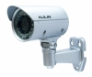
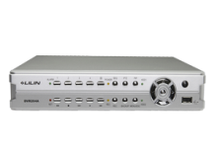
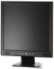
Indoor Camera Outdoor Camera DVR / NVR Monitor

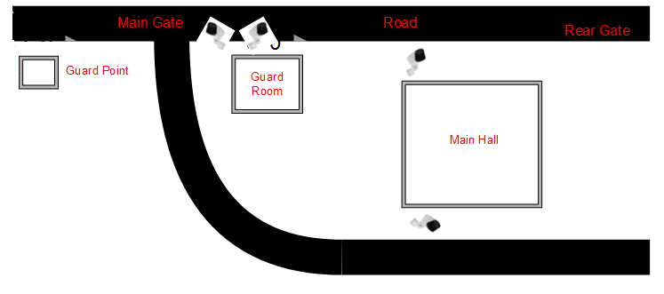
Customer Name | Sofia Katunayake (Pvt) Ltd
Drawing Title | CCTV
Issue No | RE/TE
Issue Date | 25/10/2018
Revision No | 01
Revision Date
Created By | Nirmala Iddawala
Approved By

